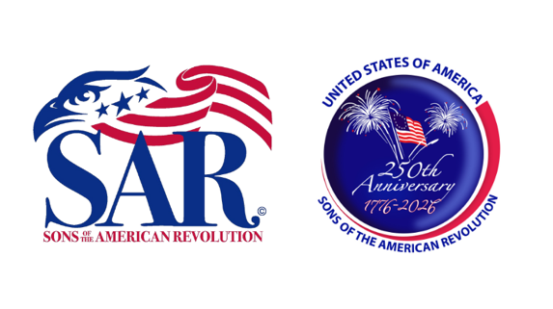
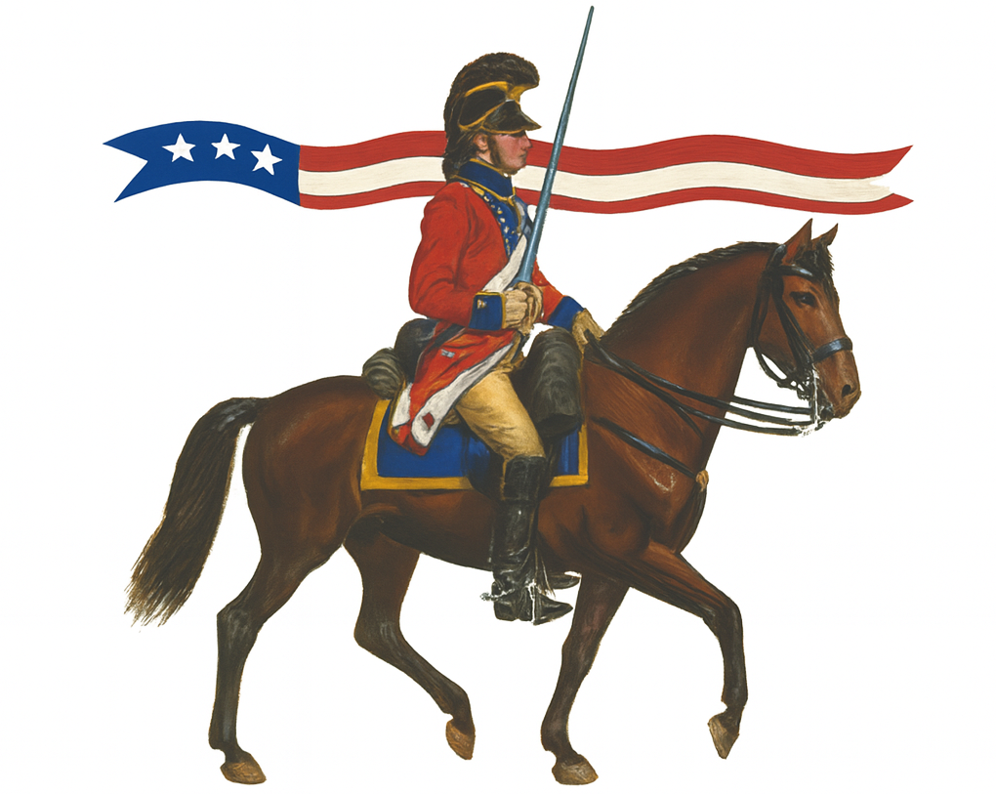
AMERICA250
SOUTH CAROLINA TRIP
NOVEMBER 12-16, 2025
Visit Fort Moultrie, Charleston, and Camden
Attend Annual SC Rev War Symposium

America250 South Carolina Trip (12-16 November 2025)
Everyone welcome. SAR membership NOT required.

NOTE: Travel via private auto, and please make hotel reservations on your own.

QUESTIONS: Contact Bob Amason * doctorbobamason@gmail.com * 904-4607616

Suggested Itinerary

November 12
Depart: St Augustine 10:00 a.m. (or your home, as desired)
Lunch: Twin Oaks BBQ, Brunswick, GA, 12:00 p.m. (or as desired)
Arrive: Mt Pleasant, SC: 4:00 p.m.
Holiday Inn Express & Suites Charleston NE Mt Pleasant US17
1104 Stockade Ln, Mt Pleasant, SC 29466•(843) 216-0000
(https://www.ihg.com/holidayinnexpress/hotels/us/en/mount-pleasant/chsmt/hoteldetail )
Evening gathering (BYOB) – Lobby: 5:00 p.m.
Dinner – Several very nice restaurants are nearby

November 13
Depart: Hotel: 8:30 a.m.
Arrive: Fort Moultrie – 9:00 a.m. – Tour with Docent Norm Rickeman, author of Unsung: William Moultrie and
the Battle of Sullivan’s Island.
Depart Fort Moultrie Area: 11:00 a.m. and Lunch (as desired)
Travel to Downtown Charleston Rev War and other sites, as desired – 12:30 p.m.
Dinner: Hyman’s Seafood, Downtown Charleston – or as desired – 6:00 p.m.

November 14
Depart: Hotel: 8:00 a.m.
Arrive: Camden SC 10:30 a.m.
Visit Camden Historical Center - 10: 30 a.m.
(https://www.historiccamden.org/2023/04/13/planning-visit/)
Lunch (as desired) – 12:00 p.m.
Visit Camden Battlefield – 1:30 p.m. (not much to see here)
Visit Camden Archives and Museum – 2:30 p.m.
(https://experiencecamdensc.com/visitors/what-to-do-page/museums/camden-archives-and-museum/)
Depart: Camden, SC 4:00 p.m.
Travel to Columbia SC
Arrive: Columbia, SC 4:30 p.m.
Fairfield Inn & Suites Columbia Northeast
120 Blarney Dr, Columbia, SC 29223
(https://www.marriott.com/en-us/hotels/caefs-fairfield-inn-and-suites-columbia-northeast/overview/)
Evening gathering (BYOB) – Lobby: 5:00 p.m.
Dinner – Several venues in the immediate area (Highly recommend Jasmine Asian Buffet)

November 15
Depart Hotel: 0820
Arrive: SC Archives and History Center 0830
Attend - 2025 South Carolina Rev War Symposium 9:00 a.m. – 4:30 p.m. (Includes lunch)
SC Archives & History Center 8301 Parklane Road Columbia, SC 29223
SYMPOSIUM PROGRAM AND REGISTRATION link (early registration ends 31 July): (https://scarchivesandhistoryfoundation.org/2025/07/01/2025-annual-american-revolution-symposium/ )
Evening gathering (BYOB) – Lobby: 5:00 p.m.
Dinner – Several venues in the immediate area
November 16: Return (as desired)

